WEBCAST: The Cambrian Explosion of Life with Paleontologist Karma Nanglu
The webcast program will be broadcast at 11am and 2pm ET on March 12, 2020. A recording of the live broadcast will be available later that evening.

Participation Logistics
- Participate in the webcast here: https://naturalhistory.si.edu/education/distance-learning/cambrian-explosion-life-paleontologist-karma-nanglu
- There will be a short video looping on this webpage before the live programs begin. The live shows should automatically start playing at 11am and 2pm ET. If they do not, try refreshing your page.
- See our Webcast Technology Guide (PDF) for troubleshooting guidance
- Email ScienceHow@si.edu on if you continue to have connectivity problems.
- Go directly to Slido.com/ScienceHow on any device to use the chat and polls on a separate device.

Pre- and Post- webcast Resources:
- Watch this 1-minute video with students to introduce them to Paleontologist Karma Nanglu: https://www.youtube.com/watch?v=sbjQpByvkn8&feature=youtu.be
- Distribute the student worksheet for activity and discussion suggestions: https://naturalhistory.si.edu/sites/default/files/media/file/student-worksheet-science-how-cambrian-explosion-life-compr-pixv2.docx for use before and after the live webcast.
- Submit your students’ questions: Send students’ questions to ScienceHow@si.edu
Background Information for Teachers
The Cambrian Period lasted from about 541-484 million years ago. During this period, we see the rapid appearance in the fossil record of nearly every major animal group for the first time, a phenomenon we call the Cambrian Explosion. A few things make the Cambrian Explosion so amazing. The first is the speed with which it occurred. While this first major diversification of animal life may have taken millions of years, in geologic terms, it was really quite brief for such an important event. Second, while these animals were still very different from those we see today, they have critical morphological features that allow us to tie them to modern animal groups. They're both recognizable and alien, and because they are so old, they give us the best opportunity for understanding the origins of modern biodiversity.
More about Early Life on Earth: https://naturalhistory.si.edu/education/teaching-resources/life-science/early-life-earth-animal-origins

Live Webcast Format- What to Expect
- Introduction- The hosts will provide a logistical overview and will introduce students to Paleontologist Dr. Karma Nanglu. a scientist at the Smithsonian’s National Museum of Natural History.
- The Cambrian Explosion- Karma will introduce students to the Cambrian Explosion of Life by way of fossils. He’ll explain the extreme nature of excavating Cambrian fossils from a field site called the Burgess Shale and will show students where the Smithsonian stores its collection of Burgess Shale fossils.
- Reading Fossils- Karma will invite students to more closely at the Cambrian Period fossils and the alien-like animals that are fossilized in the rocks. He’ll show students how finding patterns can help scientists understand certain body parts, which can help them understand certain behaviors and clues to evolutionary histories of animals alive today.
- Polls and Student Q&A- There will be three interactive polls during the program. Karma will also take questions throughout the program, and will answer as many as he can after the final segment of the program.

Additional resources related to the webcast are available in the Smithsonian Learning Lab collection, https://learninglab.si.edu/collections/the-cambrian-explosion-of-life-with-palentologist-karma-nanglu/toEPEHkTE91q295a
Student Worksheet Answers & Discussion Guides

Imagining Ancient Animals: Draw a line to match the fossil with the correct illustration.
Teacher Key: Extend the conversation with your students by having them share what patterns they saw, what looked familiar, what looked strange. Ask if they know of any other animals that have hard exoskeleton, tails, or antennae. What does this say about their potential behaviors?
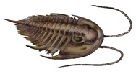
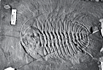
Animal: Olenoides (a trilobite; arthropod)
Look for: hard body covering (exoskeleton), segmented body, antennae, eye spots, tail
Possible behaviors: could sense its surroundings with antennae and eye spots
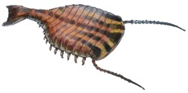
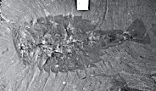
Animal: Sidneyia (arthropod)
Look for: hard body covering, segmented body, wide body, tail, antennae, eye spots
Possible behaviors: sensed its surroundings; swam short distances with its tail
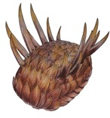
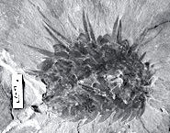
Animal: Wiwaxia (mollusk)
Look for: slug-shaped body covered in plates and spines
Possible behaviors: crawled across the ocean floor with a muscular foot; used spines and plates for protection against predators.

Imagining Ancient Animals pt 2: Circle the sketch in the field notebook that matches the fossils at right. Try tracing over the animal’s features on the picture of the fossil.
Teacher Key: The sketches in the field notebook were drawn by Paleontologist Charles Doolittle Walcott on August 31, 1909, and document his discovery of several Cambrian Period fossils from the Burgess Shale. The sketch circled, and the fossil at right, represent an animal called Marrella, which is an extinct genus of arthropod. This journal entry can be used to start a conversation about how drawing and sketching what you see — no matter how simple — can be a really important record for yourself and others.

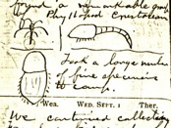

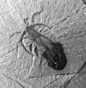

You be the scientist: Look closely at the fossil below and notice its features, like body shape and repeating patterns. Try drawing a simple sketch of the animal. If you’re not sure where to start, trace over the body parts on the fossil before you start your own sketch.
Teacher Key: The purpose of this exercise is to provide a chance for students to look closely at a fossil and try to try some of the main patterns they see. The animal is a Hallucigenia, an extinct animal that some scientists believe is most closely related to worms.

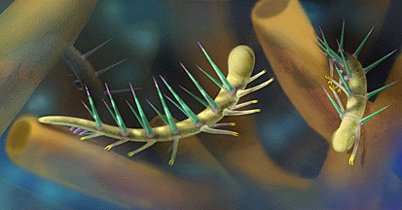
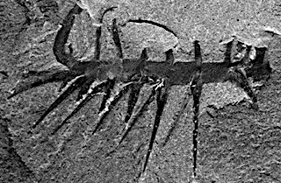

Make predictions: There are no wrong answers! Creativity is important while “reading” fossils.
- Are there any features that look familiar to you? Did you see any repeating shapes or patterns? Look for sharp spines and small limbs on its underside.
- Do you notice the sharp spines? What do you think they were used for? Protection
- How do you think this animal moved? On the underside of this animal’s body, opposite of the sharp spines, there are several pairs of legs.
Information and fossils images of each species included in the worksheet are available via the Smithsonian Learning Lab: http://learninglab.si.edu/q/ll-c/toEPEHkTE91q295a
Next Generation Standards Alignment
3rd Grade Life Science
- 3-LS3-1 Analyze and interpret data to provide evidence that plants and animals have traits inherited from parents and variation of these traits exists in a group of similar organisms.
- 3-LS3-2 Use evidence to support the explanation that traits can be influenced by the environment
- 3-LS4-1 Analyze and interpret data from fossils to provide evidence of the organisms and the environments in which they lived long ago.
  - Disciplinary Core Idea, LS4.A: Evidence of Common Ancestry and Diversity
    - Some kinds of plants and animals that once lived on Earth are no longer found anywhere (3-LS4-1)
    - Fossils provide evidence about the types of organisms that lived long ago and also about the nature of their environments. (3-LS4-1)
- 3-LS4-4 Make a claim about the merit of a solution to a problem caused when the environment changes and the types of plants and animals that live there may change.
  - Disciplinary Core Ideas, LS2.C: Ecosystem Dynamics, Functioning, and Resilience
    - When the environment changes in ways that affect a place’s physical characteristics, temperature, or availability of resources, some organisms survive and reproduce, others move to new locations, yet others move into the transformed environment, and some die. (3-LS4-4)
4th Grade Life Science
- 4-LS1-1 Construct an argument that plants and animals have internal and external structures that function to support survival, growth, behavior, and reproduction.
4th Grade Earth Science
- 4-ESS1-1 Identify evidence from patterns in rock formations and fossils in rock layers to support an explanation for changes in a landscape over time.
5th Grade Life Science
- 5-LS2-1 Develop a model to describe the movement of matter among plants, animals, decomposers, and the environment.
  - Disciplinary Core Idea, LS2.A: Interdependent Relationships in Ecosystems
    - The food of almost any kind of animal can be traced back to plants. Organisms are related in food webs in which some animals eat plants for food and other animals eat the animals that eat plants.
Middle School Life Science (Grades 6-8)
- MS-LS4-1 Analyze and interpret data for patterns in the fossil record that document the existence, diversity, extinction, and change of life forms throughout the history of life on Earth under the assumption that natural laws operate today as in the past.
- MS-LS4-2 Apply scientific ideas to construct an explanation for the anatomical similarities and differences among modern organisms and between modern and fossil organisms to infer evolutionary relationships.
Middle School Earth Science (Grades 6-8)
- MS-ESS1-4 Construct a scientific explanation based on evidence from rock strata for how the geologic time scale is used to organize Earth’s 4.6-billion-year-old history.

